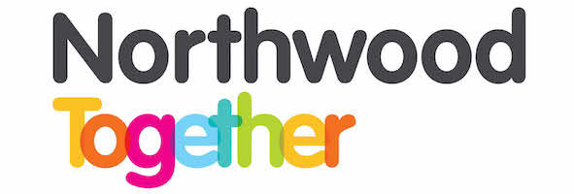
s
Northwood Together Partnership Board Meeting
Tuesday 9th November 2021
Action Notes
Board Members Present:  Board Advisor’s Present:  Apologies:  Observers: | Ally Middleton, Debi O’Shea, Joan Ford, Carol Birchall, Gail Ross, Sam Roberts, Sarah Smith  Lisa Cover  Andrea Hawksey, Tim Edwards
1. Welcome & Introductions
The confidentiality agreement was signed by those present.
2. Confidentiality Agreement/Declarations of Interest/Quorate
Meeting declared as quorate.
Ally reminded all members of our confidentiality agreement.
No one declared any declarations of interest.
3. Note of Last Meeting & Matters Arising
The notes of the last meeting were agreed.
4. Financial Update
Joan gave a detailed update on our current financial situation.
5. Funding Applications
None.
6. Project Update
Lisa gave a brief project update.
It was agreed to fund the support worker an additional day a week for six months.

7. Management Arrangements
N/A
8. Governance Issues
Ally advised Board that Carly Colburn has stepped down as a board member.
9. Delivery Plan
The delivery plan is almost complete and will be reviewed at the board meeting in December. The plan will then be submitted.
10. Plan Review
Lisa confirmed that the plan review had been submitted.
11. Any Other Business
It was agreed to auction off the Trent signed LFC shirt and the Joe Gomez shirt be used in the Christmas raffle.
Christmas Hampers
The hamper delivery date is 21 December 2021.
Date of Next Meeting: Tuesday ^{14th} December 2021 at 10.00am at Northwood Community Centre

Action Table
Agenda Item | Action | Responsible
Governance | Lisa to invite Andrea in for her induction | Lisa

